 | Year 11 Mathematics  Methods Unit 1 | Test 1  Term 1, 2021  Test date: Thursday 4th March
Student Name: ______________________________________________________________________
 | Total | Result | %
Section 1 | 17
Section 2 | 33
Total | 50
All working must be shown in the space provided. Your working should be in sufficient detail to allow your answers to be checked readily and for marks to be awarded for reasoning. Incorrect answers given without supporting reasoning cannot be allocated any marks. For any question or part question worth more than 2 marks, valid working or justification is required to receive full marks.

Section 1: Resource – Free | Working time: 20 minutes

Question 1 [1, 2, 2, 2 = 7 marks]
Consider the two right triangles shown below.

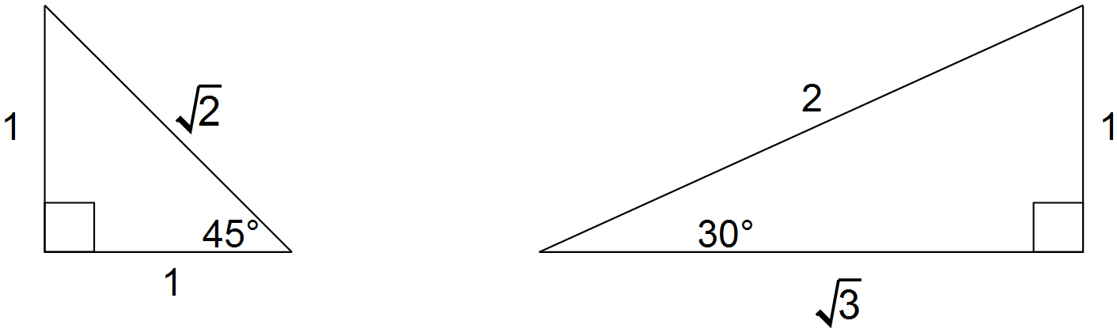

Use the triangles above and reference angles to determine the exact value of

(a) cos 60°

(b) sin 225°

(c) θ , where tan θ = for 0 ≤ θ ≤ 360°

(d) Use the triangle from page 1 (showing an angle of ${30}^{0}$)
to demonstrate that $\frac{\sin{θ}}{cosθ}=\tan{θ}$

Question 2 [1, 2 = 3 marks]
Use the unit circle below to answer the questions on the right.
Give your answers to an appropriate degree of accuracy.
(a) Determine the value of sin 120°

(b) Solve for $x$ where $\cos{x= -0.8 and 0^{o}}≤x≤{360}^{o}$

Question 3 [2 marks]

(a) Convert $\frac{5π}{6}$ radians to degrees

(b) Express $-285°$to radians , as a fraction of $π.$

Question 4 [3, 2 = 5 marks]

(a) Find the exact value of $x^{2}$ showing full setting out.
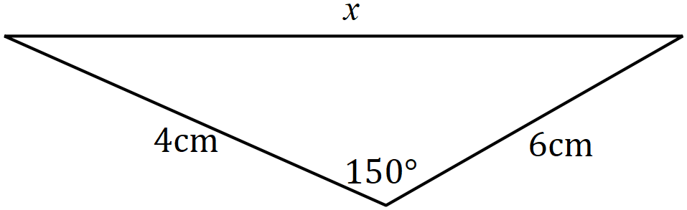

(b) Calculate the area of the triangle.

End of Section 1
 | Year 11 Mathematics  Methods Unit 1 | Test 1  Term 1, 2021  Test date: Thursday 4th March
Student Name: ______________________________________________________________________
 | Total | Result | %
Section 1 | 17
Section 2 | 33
Total | 50
All working must be shown in the space provided. Your working should be in sufficient detail to allow your answers to be checked readily and for marks to be awarded for reasoning. Incorrect answers given without supporting reasoning cannot be allocated any marks. For any question or part question worth more than 2 marks, valid working or justification is required to receive full marks.

Section 2: Resource – Rich | Working time: 35 minutes

Question 1 [8 marks]

(a) Determine the area of triangle $PQR$ when $∠PQR=26°$, $∠PRQ=122°$ and $PQ=57$ cm.
(4 marks)

(b) The area of triangle $ABC$ is $96$ cm², $∠ACB=30°$ and $2BC=3AC$ as shown in the diagram. Determine the value of $x$and then calculate the length of $AB$. (4 marks)
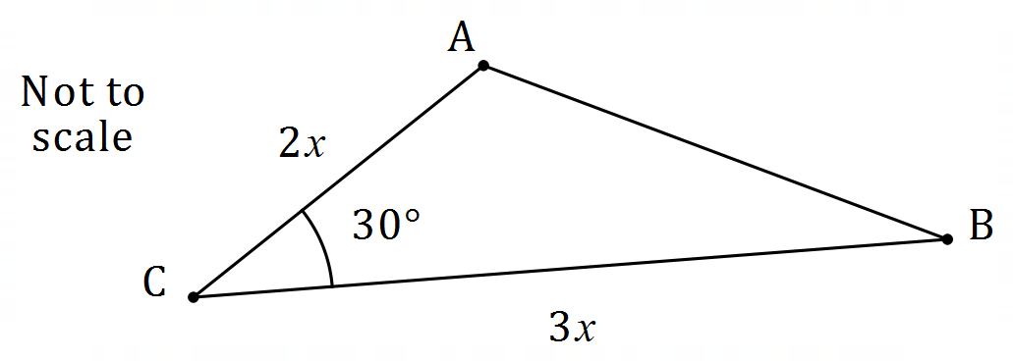

Question 2 [2, 3 = 5 marks]

A segment of a circle of radius $22$ cm is shown below, where $θ=\frac{7π}{10}$.

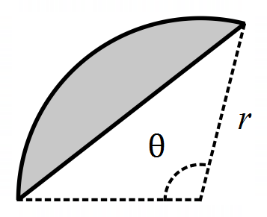

(a) Determine the area of the segment. (2 marks)

(b) Determine the perimeter of the segment. (3 marks)

Question 3 [5 marks]

Shape $AOBCDA$ below consists of sector $BOC$ of circle centre $O$ joined to sector $DOA$ of a different circle, also centre $O$. $AB$ is a line of length $65$ cm, arc $AD$ is $12$ cm long and $∠AOD=0.32$ radians.
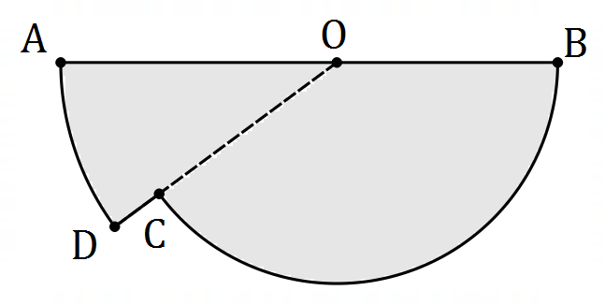

(a) Determine the length $OA$. (2 marks)

(b) Determine the area of the shape. (3 marks)

Question 4 [3 marks]

Calculate, to the nearest degree, the acute angle between the line $y=1.5x-4$
and the line $y=-0.5x+4$.

Question 5 [6 marks]

Determine, correct to 2 decimal places, the length of side BD in the diagram below.

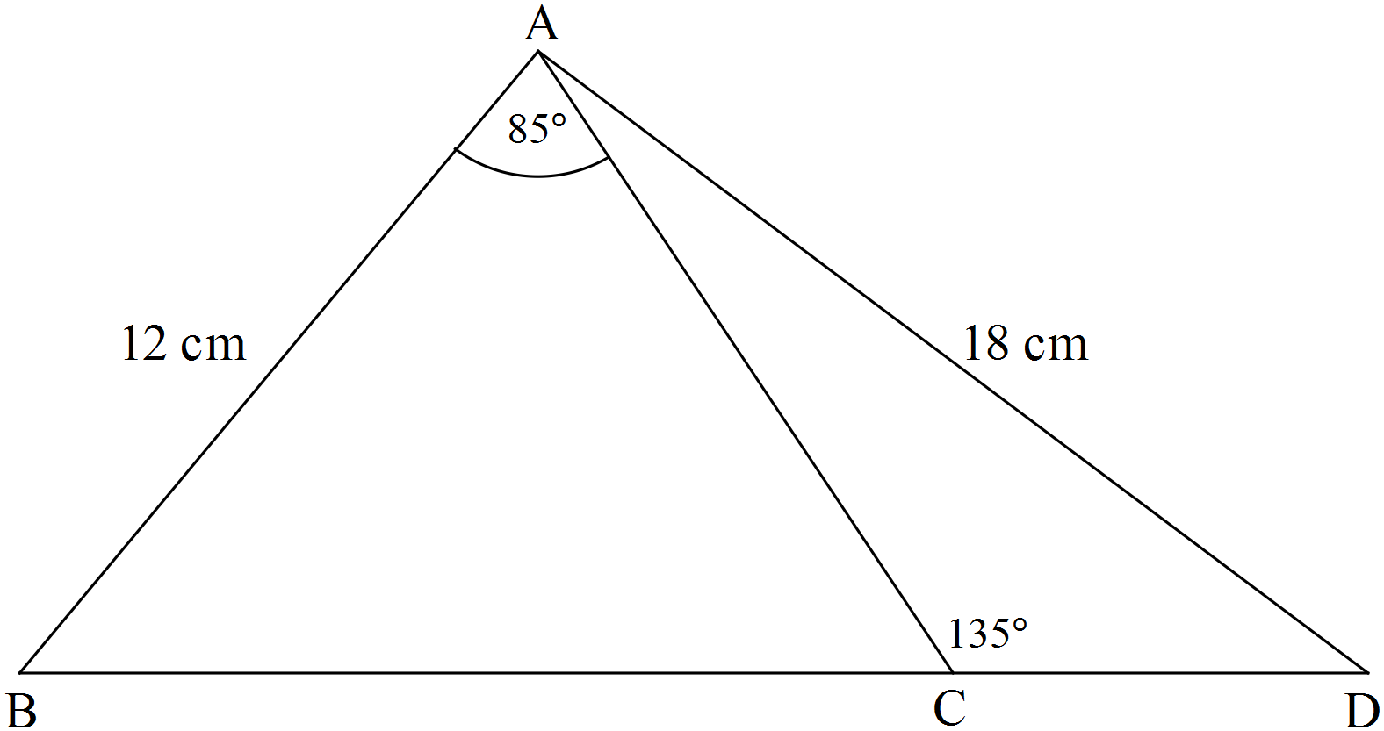

Note: the diagram is not drawn to scale.

Question 6 [1, 2, 3 = 6 marks]

A boat sails from A in the direction ${125}^{o}$ for 40 km. It then sails along ${210}^{o}$ for 100 km.
(a) Complete the diagram below to show this information. (1 mark)

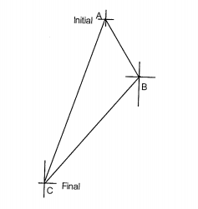

(b) Calculate the direct distance between A and its final position. (2 marks)

(c) Find the bearing of A from its final position. (3 marks)

End of Section 2

